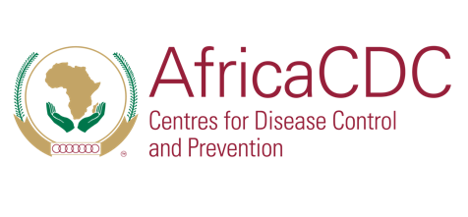
Safeguarding Africa’s Health

Directorate of Communication and Public Information (CPI)

INVITATION TO REPRESENTATIVES OF THE MEDIA

WHAT: Africa CDC Director-General Special Press Briefing
WHEN: Thursday, 22nd January 2025

TIME: 16:00hrs – 17:30hrs | East Africa Time (GMT +3)

WHERE: Virtual (Zoom)

REGISTRATION: https://ow.ly/kOxL50XZAmT

Overview:

In light of the evolving public health situation on the African continent, the Director General of Africa Centres for Disease Control and Prevention (Africa CDC) will hold a special press conference, joined by a Special Guest, the Minister of Public Health of Guinea-Bissau, to address critical health priorities and ongoing preparedness efforts.

The press conference will cover the following key issues:
- The Mpox outbreak response
- The Hepatitis B situation in Guinea-Bissau
- Preparations for key health-related side events on the margins of the upcoming African Union Assembly

SPEAKERS:
- H.E. Dr Jean Kaseya, Director General, Africa CDC
- H.E. Mr. Quinhin Nantote, Minister of Public Health, Guinea-Bissau
Interpretation in French and Portuguese will be available.

MEDIA INQUIRIES:

Margaret Muigai Edwin, Director of Communication & Public Information Directorate: Africa CDC | Tel: +255 742 635 592 | Email: edwinm@africacdc.org

About Africa CDC
The Africa Centres for Disease Control and Prevention (Africa CDC) is a public health agency of the African Union. It is autonomous and supports member states in strengthening health systems. It also helps improve disease surveillance, emergency response, and disease control. Learn more at: http://www.africacdc.org and connect with us on LinkedIn, Twitter, Facebook and YouTube

