Outbreak Brief #48: Coronavirus Disease 2019 (COVID-19) Pandemic
Date of Issue: 15 December 2020
71,062,725 cases and 1,608,963 deaths
Data sources: World Health Organization and African Union Member States
Outbreak Update: Since the last brief (8 December 2020), 4,611,213 new confirmed coronavirus disease 2019 (COVID-19) cases and 75,990 new deaths have been reported globally. To date, a total of 71,062,725 COVID-19 cases and 1,608,963 related deaths (case fatality rate (CFR): 2.3%) have been reported from 221 countries and territories. This week, no new country or territory reported its first case. The distribution of cumulative cases (proportion of global cases) from the World Health Organization (WHO) reporting regions (excluding Africa) are as follows: Eastern Mediterranean Region 3,760,027 (5%), European Region 22,116,845 (31%), Region of the Americas 30,416,759 (43%), South-East Asia Region 11,398,927 (16%) and Western Pacific Region 966,296 (1%). Among the affected locations, the United States has reported more than one million new cases each week for the last five consecutive weeks. For the last seven days, Brazil, India and Turkey have reported over 200,000 new cases each. For more detailed information on cases and deaths being reported outside of Africa, refer to the WHO daily situation reports.
As of 9 am East African Time (EAT) 15 December 2020, a total of 2,389,975 COVID-19 cases and 56,647 deaths (CFR: 2.4%) have been reported in 55 African Union (AU) Member States. This is 3.4% of all cases reported globally. The majority (84%) of Member States continue to report community transmission. Of the countries actively reporting COVID-19 epidemiologic data, sixteen countries are reporting case fatality rates higher than the global case fatality rate of 2.3%. These include Sahrawi Arab Democratic Republic (7.1%), Sudan (6.3%), Chad (5.8%), Egypt (5.7%), Liberia (5%), Niger (3.5%), Tunisia (3.5%), Mali (3.4%), Gambia (3.3%), Malawi (3.1%), Sierra Leone (3.1%), Algeria (2.8%), South Africa (2.7%), Zimbabwe (2.7%), Somalia (2.6%) and Democratic Republic of Congo (2.5%).
For Epi week 50 (7 December - 13 December), 115,849 new COVID-19 cases have been reported, which is a 16% increase in the number of new cases reported compared to Epi week 49. The majority of new COVID-19 cases being reported for this week are from the Southern region (46%) followed by the Northern (34%), Eastern (12%), Western (7%) and Central (2%) regions. Countries reporting the highest incidence (COVID-19 new cases per 100,000 population) this week include Botswana (95), South Africa (80), Tunisia (60), Namibia (56), Libya (56), Morocco (55) and Cape Verde (49).
Table 1 highlights the reported cases and deaths from COVID-19 in all countries in Africa for Epi week 50. The table reports the current phase of the epidemic for each country. Figure 1 shows the trend of new COVID-19 cases reported by day and region from 15 February to date. A second wave of the pandemic is now affecting Africa as cases have continued to increase over the last two months, the majority of these cases are reported from the Southern region. This week, four countries account for about 67% of the new COVID-19 cases reported: South Africa (40%), Morocco (17%), Tunisia (6%), Uganda (4%).
Table 1. Confirmed COVID-19 cases, deaths and recoveries reported in Africa for Epi week 50 (7 December - 13 December 2020)
Country | Number of cases  (new) | Percent change in new cases since the previous Epi week (49) | Number of deaths (new) | Percent change in new deaths since the previous Epi week (49) | Epidemic phase
Central Region | 68,665 (1,781) | 11% | 1,229 (20) | 5%
Burundi | 729 (35) | 169% | 1 (0) | NA* | 3
Cameroon | 25,143 (391) | -38% | 443 (0) | -100% | 3
Central African Republic | 4,936 (4) | -71% | 63 (0) | NA* | 3
Chad | 1,771 (46) | 24% | 102 (0) | -100% | 3
Congo | 6,049 (275) | NA* | 99 (5) | NA* | 3
Democratic Republic of Congo | 14,513 (918) | 12% | 356 (12) | 9% | 3
Equatorial Guinea | 5,185 (26) | 767% | 85 (0) | NA* | 3
Gabon | 9,330 (76) | 21% | 63 (3) | 200% | 3
Sao Tome and Principe | 1,009 (10) | No change | 17 (0) | NA* | 3
Eastern Region | 298,327 (13,799) | -6% | 5,569 (190) | -2%
Comoros | 628 (12) | 140% | 7 (0) | NA* | 3
Djibouti | 5,728 (27) | 13% | 61 (0) | NA* | 2
Eritrea | 711 (79) | 44% | (0) | NA* | 1
Ethiopia | 116,769 (3,474) | -8% | 1,806 (59) | 26% | 3
Kenya | 91,892 (3,512) | -31% | 1,587 (61) | -18% | 3
Madagascar | 17,587 (0) | -100% | 259 (0) | -100% | 3
Mauritius | 515 (10) | 150% | 10 (0) | NA* | 2
Rwanda | 6,659 (530) | 152% | 56 (5) | 67% | 2
Seychelles | 187 (3) | -73% | (0) | NA* | 1
Somalia | 4,579 (54) | -27% | 121 (0) | -100% | 1
South Sudan | 3,206 (25) | -65% | 62 (0) | -100% | 3
Sudan | 21,591 (1,507) | -26% | 1,355 (48) | -8% | 3
Tanzania | 509 (0) | NA* | 21 (0) | NA* | 3
Uganda | 27,766 (4,566) | 49% | 224 (17) | 183% | 3
Northern Region | 827,003 (39,692) | -17% | 21,518 (951) | -19%
Algeria | 92,102 (3,850) | -36% | 2,596 (86) | -26% | 3
Egypt | 121,575 (3,143) | 9% | 6,898 (127) | -6% | 2
Libya | 91,357 (4,260) | -1% | 1,314 (59) | -18% | 3
Mauritania | 10,971 (1,455) | 50% | 225 (37) | 185% | 3
Morocco | 399,609 (19,952) | -23% | 6,589 (344) | -25% | 2
Tunisia | 111,361 (7,032) | -13% | 3,894 (298) | -21% | 3
Sahrawi Arab Democratic Republic | 28 (0) | NA* | 2 (0) | NA* | 1
Southern Region | 967,774 (53,005) | 77% | 25,019 (1,134) | 48%
Angola | 16,188 (652) | 51% | 371 (17) | 113% | 3
Botswana | 12,501 (2,491) | 13739% | 38 (4) | 33% | 3
Eswatini | 6,768 (267) | 193% | 127 (5) | 400% | 3
Lesotho | 2,277 (127) | 210% | 44 (0) | NA* | 3
Malawi | 6,066 (15) | -42% | 187 (2) | NA* | 3
Mozambique | 16,954 (710) | 13% | 142 (9) | 200% | 3
Namibia | 16,536 (1,458) | 99% | 160 (8) | 700% | 3
South Africa | 860,964 (46,399) | 73% | 23,276 (1,070) | 47% | 3
Zambia | 18,274 (358) | 16% | 367 (3) | -57% | 3
Zimbabwe | 11,246 (528) | -31% | 307 (16) | 7% | 3
Western Region | 218,517 (7,572) | 37% | 2,975 (71) | 69%
Benin | 3,090 (17) | -83% | 44 (0) | -100% | 3
Burkina Faso | 4,030 (818) | 130% | 71 (3) | NA* | 3
Cape Verde | 11,357 (294) | -19% | 110 (1) | -75% | 3
Côte d’Ivoire | 21,680 (195) | 11% | 133 (1) | No change | 3
Gambia | 3,782 (15) | -55% | 123 (0) | NA* | 3
Ghana | 53,014 (276) | -74% | 327 (1) | -67% | 3
Guinea | 13,431 (185) | 24% | 79 (2) | 100% | 3
Guinea-Bissau | 2,444 (3) | NA* | 44 (0) | NA* | 3
Liberia | 1,676 (0) | -100% | 83 (0) | NA* | 3
Mali | 5,814 (679) | 52% | 194 (30) | 150% | 3
Niger | 2,258 (402) | 18% | 80 (3) | -57% | 3
Nigeria | 73,175 (3,920) | 113% | 1,197 (17) | 143% | 3
Senegal | 17,075 (598) | 49% | 349 (11) | 120% | 3
Sierra Leone | 2,440 (14) | -7% | 75 (1) | NA* | 3
Togo | 3,251 (156) | 17% | 66 (1) | No change | 3
Total | 2,380,286 (115,849) | 16% | 56,310 (2,366) | 8%
*No new cases/deaths reported in the previous week.

Figure 1: New COVID-19 cases reported by day and AU region, 15 February - 15 December 2020
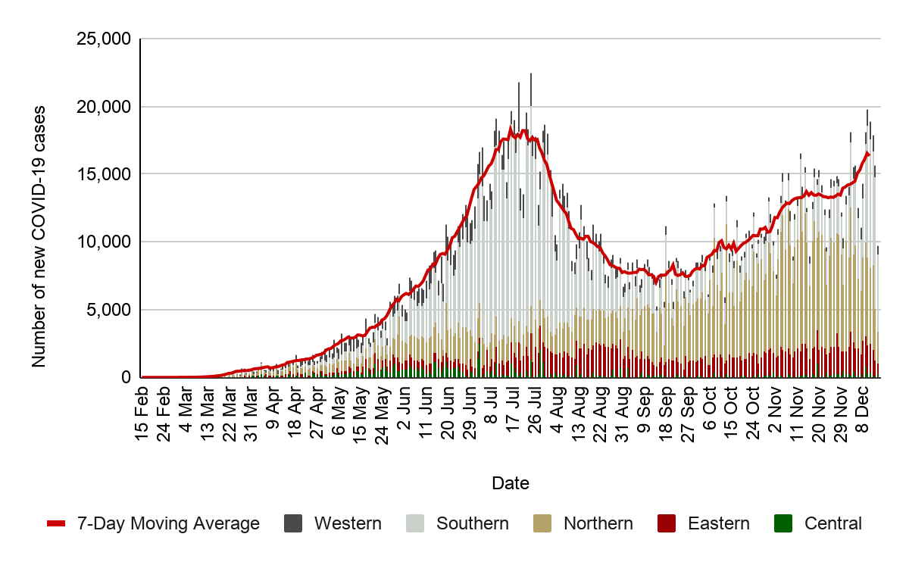

NEW Africa CDC Response Activities:
General:

- H. E the Commissioner for Social Affairs, Amira Elfadil; H. E the Commissioner for Human Resources of Science & Technology, Prof. Sarah Agbor of African Union; and H.E. Ambassador of the Chinese Mission to the AU, Liu Yuxi jointly unveiled the new Africa CDC headquarters building project on Monday, 14 December 2020 at 11 am EAT. The project site is located at the Africa village in Addis Ababa, Ethiopia. Link: https://twitter.com/AfricaCDC/status/1338407852407451649?s=20
- This week, Dr John Nkengasong, the Director of the Africa CDC was honoured in New African Magazine as one of the “100 Most Influential Africans”.
- Africa CDC Deputy Director, Dr Ahmed Ogwell, visited the Southern Regional Collaborating Centre (RCC) in Lusaka, Zambia from 6 to 9 December 2020 to meet with Zambian officials about expanding the RCC.
- Last week, Dr. Nkengasong hosted Africa CDC’s weekly press briefing on Thursday 10 December 2020 at 11 am EAT. The recording for the press brief is available on the Africa CDC Facebook page.
- Africa CDC Public Health Emergency Operations Centres (PHEOCs) and COVID-19 Management will hold its weekly PHEOC webinar series on Multisectoral Coordination titled “Developing and Using Concept of Operations in PHEOCs” on Thursday, 17 December 2020 at 3 pm EAT. Registration link: bit.ly/3jxGzv9

Healthcare Preparedness and Medical Countermeasures:
Case Management
- The Africa CDC Case Management Technical Working Group (TWG) held its 34th clinical webinar series titled “COVID-19 and pediatric surgery considerations” on Thursday, 10 December 2020 for over 200 participants. The recording can be accessed here: CCOP | Africa CDC Institute
- The Africa CDC Case Management TWG held its eighth Mental Health Aspects of COVID-19 session titled “Mental health experiences of frontline workers and patients’’ on Thursday, 10 December 2020 for over 100 participants. The recording can be accessed here: Webinar Series on Mental Health Aspects of COVID-19

Laboratory:
- Over 23.7 million tests for COVID-19 have been conducted to date with a positivity rate of 10% and test per case ratio of 10, which is a 4.04% increase from last week.
- Africa CDC Laboratory has procured 2.9 million antigen tests from different partners and more than 700,000 have been distributed to Member States.

Surveillance
- Africa CDC is currently supporting and implementing COVID-19 seroprevalence survey studies in 18 Member States. Four countries are at the implementation stage, seven countries at the advanced planning stage and seven countries at the planning stage.

Sciences, Standards and Regulations:
- Access the weekly COVID-19 Scientific and Public Health Policy Update which is published every other week on Tuesdays at https://africacdc.org/resources/ or the WHO AFRO link: https://afrolib.afro.who.int/pmb/opac_css/doc_num.php?explnum_id=7728
- This week the Partnership for Evidence-Based Response to COVID-19 (PERC) released their bi-weekly report, which can be accessed on both the PERC and Africa CDC website.

Recommendations for the Member States:
- All Member States should continue to enhance their surveillance to include COVID-19 and severe acute respiratory infections (SARI). Examples of enhanced surveillance include:
  - Adding questions about travel, contact history, and testing for coronaviruses to existing influenza surveillance systems;
  - Notifying healthcare facilities to immediately inform local public health officials about persons who meet the case definition for COVID-19, SARI and/or have recent travel to a country with local transmission or history of contact with a case.
- Member States should perform contact tracing of confirmed cases based on transmission type and country capacity.
- Member states should notify and routinely share with WHO and Africa CDC data regarding suspected or confirmed COVID-19 cases, deaths, recoveries, tests conducted and healthcare workers infected to continually inform these and other updates. Notify Africa CDC by emailing: AfricaCDCEBS@africa-union.org.
- Member states should continue to guide the general public about seeking immediate medical care and informing healthcare providers about recent travel or contact history in anyone who develops symptoms of severe respiratory illness.
Resources for more information:
Africa CDC Resources
- Africa CDC COVID-19 updates: https://africacdc.org/covid-19/
- Multimedia: https://africacdc.org/covid-19-multimedia/
- Resources, policy guidelines, and infographics: https://africacdc.org/covid-19/covid-19-resources/

Other Resources
- European Centre for Disease Prevention and Control. https://www.ecdc.europa.eu/en/novel-coronavirus-china
- US Centers for Disease Control and Prevention. Coronavirus disease 2019 (COVID-19). https://www.cdc.gov/coronavirus/novel-coronavirus-2019.html
- WHO. Technical Guidance. https://www.who.int/emergencies/diseases/novel-coronavirus-2019/technical-guidance

WHO COVID-19 surveillance guidance and case definition: https://www.who.int/publications/i/item/who-2019-nCoV-surveillanceguidance-2020.7
WHO coronavirus disease (COVID-19) dashboard: https://covid19.who.int/
Data is continuously verified for accuracy and reliability however it may change based on retrospective updates from Member States.
Phases defined according to Africa CDC’s Recommendations for a stepwise COVID-19 response - https://africacdc.org/download/recommendations-for-stepwise-response-to-covid-19/: Phase 0 (No COVID-19 case): no reported case in-country; Phase 1 (Early stage outbreak): one or more imported cases, limited local transmission related to imported cases; Phase 2 (Expanding outbreak): increasing number of imported cases, increased local spread but all cases linked to known transmission chains, outbreak clusters with a known common exposure; Phase 3 (Advancing outbreak): localized outbreaks start to merge, one or more cases or deaths occur outside known transmission, multiple generations in transmission chains, cases are detected among severe acute respiratory illness (SARI) case with no known exposure; Phase 4 (Large outbreak with nationwide transmission): widespread sustained community transmission, multiple generation transmission chains can be identified but most cases occurring outside of chains, community-wide transmission throughout all or nearly all of the country.
Last report received 7-May-2020.
Africa CDC Protocol for enhanced surveillance for COVID-19 in Africa: https://africacdc.org/download/protocol-for-enhanced-severe-acute-respiratory-illness-and-influenza-like-illness-surveillance-for-covid-19-in-africa/
WHO COVID-19 surveillance guidance and case definition: https://www.who.int/publications/i/item/who-2019-nCoV-surveillanceguidance-2020.7
WHO SARI case definition: anyone with an acute respiratory infection with a history of fever (or measured fever of ≥ 38 C°) and cough with symptom onset within the last 10 days that requires hospitalization. https://www.who.int/influenza/surveillance_monitoring/ili_sari_surveillance_case_definition/en/
Africa CDC Guidance on Contact Tracing for COVID-19 Pandemic: https://africacdc.org/download/guidance-on-contact-tracing-for-covid-19-pandemic/

